SCN Dementia Intelligence Report

May 2014

Produced by: | Yorkshire and The Humber Strategic Clinical Networks and Senate
Address: | 5SE, Quarry House, Leeds
Telephone: | 0113 825 3347
Document Version | 1
Publication Date | May 2014
Review Date

1 Introduction 3
1.1 Prevalence 3
2 Prevention 5
3 Diagnosis 6
3.1 CCG Diagnosis Rates 6
3.2 GP Practice Diagnosis Rates 8
3.3 Dementia Enhanced Service (DES) 9
3.4 Estimates of Mild, Moderate or Severe Diagnoses 10
3.5 Waiting Times 11
3.6 Median Waits for Diagnostic Imaging by CCG 11
3.7 Median Waits for Diagnostic Imaging by Provider 12
3.8 Memory Assessment Service 13
3.9 Local Survey (Jan 2014) 14
3.10 Dementia Commissioning for Quality and Innovation (CQUIN) 15
3.10.1 Cases Identified 15
3.10.2 Diagnostic Assessment 16
3.10.3 Referred 16
4 Post-Diagnosis 18
4.1 Prescribing Data 18
4.2 Acute Hospital Admissions 20
4.3 Anti-psychotic prescriptions 20
5 End of Life 21

Introduction

This is the first version of the Yorkshire and Humber Strategic Clinical Network Dementia Intelligence Report.

This report will be reviewed quarterly and updated when new national or local data is published.

Prevalence

The National Dementia Prevalence Rate was developed as a more accurate way to estimate the proportion of patients on a practice list who have dementia.

This takes into account the number of patients in each age group, the expected rate of dementia for this age group and then provides a total expected number of patients for each practice with dementia. This is expressed on the website both as a number of patients, and then in brackets afterwards as a percentage of the total list size. The percentage figure allows us to make a fair comparison between practices of differing list sizes.

Although the NDPR is a better estimate of Dementia prevalence than a flat figure, this was refined further in a report published in 2012 where it was suggested that we could anticipate the number of patients in a nursing or care home environment and therefore get a better estimate for dementia prevalence.

This calculation is based upon Alzheimer’s Society estimates of the rates of dementia in nursing home patients. The steps of the calculation are outlined below for a sample practice. If you wish to learn more about this methodology, please consult with the DPC team.

Initially, the practice list is split into those patients in a care home environment (taken from GP nursing home list or from entered values). The number of patients in a nursing home is split into estimated demographic groups using national estimates of age distribution. These patients are then removed from the ‘Community’ demographic.

An estimate of the ‘Community Prevalence rate’ at Area team level is calculated by looking at the area team as a whole, and assuming that on a population level the ANDPR is equal to the NDPR. The total number of patients in a nursing home and the expected rate of dementia in those patients is subtracted from the total number of patients expected to have dementia. This results in the ‘Community Prevalence Rate’ for each age demographic.

The ‘Community Prevalence Rate’ is multiplied by the community demographic split to give the estimated number of patients in the community with dementia, and the rate is this figure as a proportion of the number of patients in the community.

The number of patients in a care home with dementia is estimated from the predicted care home demographic split multiplied by the expected care home prevalence rate for that demographic group.

The ANDPR is the sum of the estimated number of patients in a care home and the estimated number of patients in the community with dementia. This is expressed as a percentage of the patient list.

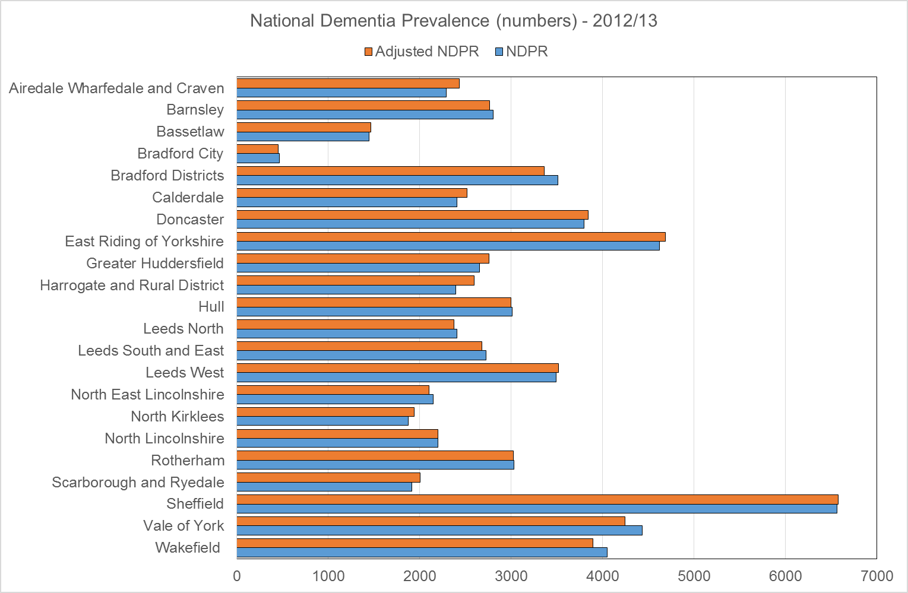

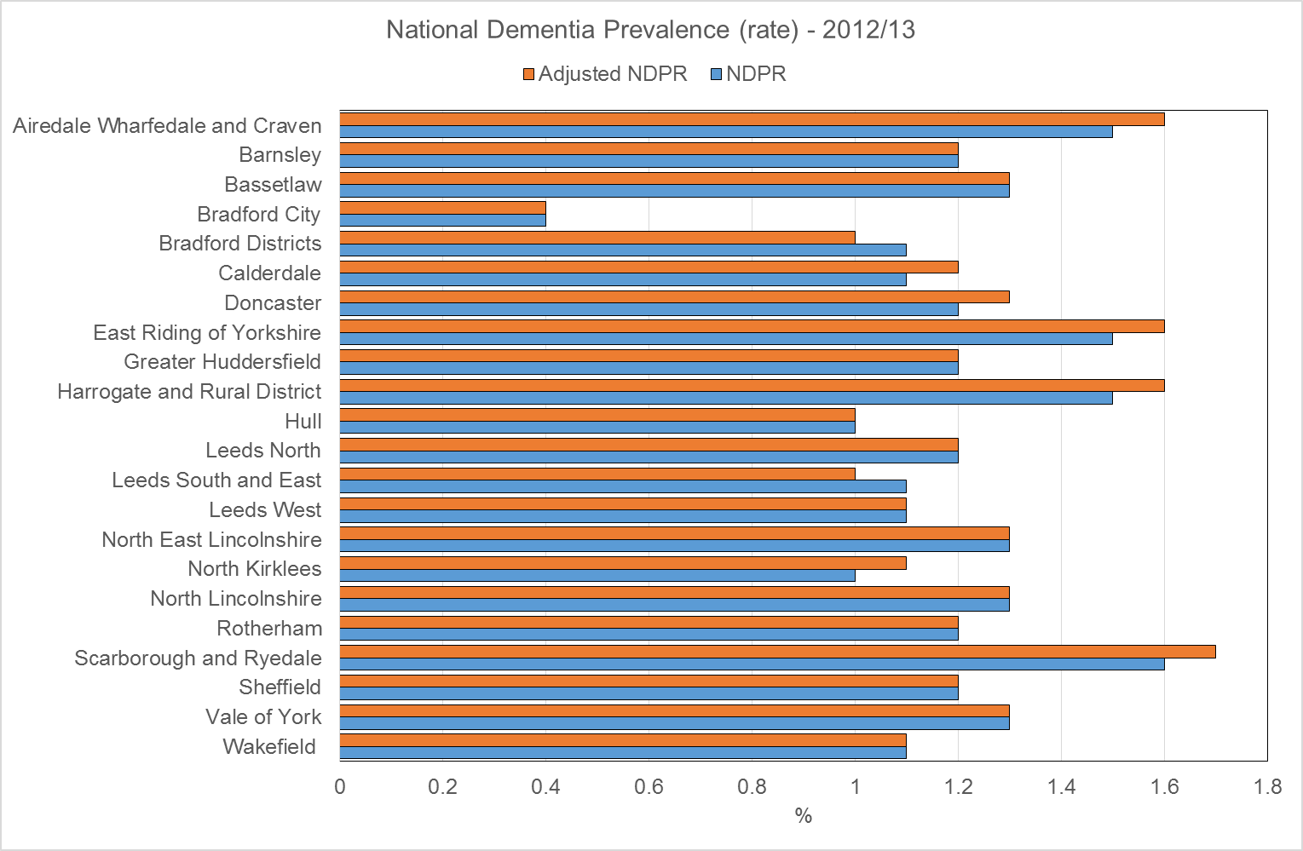

Source: National Dementia Prevalence Calculator (v3) - https://www.primarycare.nhs.uk/

Prevention
About 60% of people with dementia have Alzheimer’s disease, 20% vascular dementia and many have a mixture of the two. There are also many other less common forms of dementia.

Vascular dementia results from problems with the blood supply to the brain – and therefore the effects of vascular dementia can be minimised or prevented altogether through a healthy lifestyle.

The NHS Health Check programme offers advice and support to people aged 40-74 to make changes that can reduce the risk of ill health, including vascular dementia.

Since April 2013 people in England aged 65-74 should be given information about dementia and the availability of memory services.

Data on NHS Health Check is reported at local authority level and is available at http://www.healthcheck.nhs.uk

Local Authority | Eligible Population | Number offered health check | Number received health check | % uptake to date | % uptake overall (of eligible)
Barnsley | 72741 | 8403 (11.6%) | 5755 (7.9%) | 68.5% | 7.9%
Bradford | 134258 | 5353 (4%) | 5323 (4%) | 99.4% | 4%
Calderdale | 62759 | 9437 (15%) | 5283 (8.4%) | 56% | 8.4%
Doncaster | 90713 | 4566 (5%) | 4566 (5%) | 100% | 5%
East Riding of Yorkshire | 114099 | 7032 (6.2%) | 5433 (4.8%) | 77.3% | 4.8%
Hull | 68293 | 5873 (8.6%) | 1987 (2.9%) | 33.8% | 2.9%
Kirklees | 122000 | 24036 (19.7%) | 12809 (10.5%) | 53.3% | 10.5%
Leeds | 201249 | 30961 (15.4%) | 16770 (8.3%) | 54.2% | 8.3%
North East Lincolnshire | 45240 | 5814 (12.9%) | 2757 (6.1%) | 47.4% | 6.1%
North Lincolnshire | 53005 | 5536 (10.4%) | 3082 (5.8%) | 55.7% | 5.8%
North Yorkshire | 198903 | 19994 (10.1%) | 9780 (4.9%) | 48.9% | 4.9%
Rotherham | 79838 | 3638 (4.6%) | 3638 (4.6%) | 100% | 4.6%
Sheffield | 146697 | 19090 (13%) | 9150 (6.2%) | 47.9% | 6.2%
Wakefield | 101661 | 9375 (9.2%) | 3818 (3.8%) | 40.7% | 3.8%
York | 55311 | 8337 (15.1%) | 3649 (6.6%) | 43.8% | 6.6%
Yorkshire & Humber | 1546767 | 167445 (10.8%) | 93800 (6.1%) | 56% | 6.1%
England | 15308022 | 2022063 (13.2%) | 973093 (6.4%) | 48.1% | 6.4%

Diagnosis
On average, less than half of the estimated number of people with dementia in England have received a formal diagnosis or have contact with specialist dementia services.

There has been a slight increase nationally in the diagnosis rate from 46% in 2011/12 to 48% in 2012/13. The rate varies from 39% to 75%.

The Diagnosis rate is a key figure within the Calculator indicating the proportion of patients with Dementia on a practice list. This is calculated using the ANDPR, and the number with a diagnosis using the QOF dementia register. The ambition is to get the diagnosis rate to two-thirds of expected prevalence by March 2015. It is possible to have a diagnosis rate > 100%, if you have more patients with dementia than we expect a practice to have.

The ‘Dementia Gap’ is the number of patients on the practice list with dementia who are undiagnosed. This is calculated by subtracting the QOF dementia register from the ANDPR number, and expressing that figure as a percentage of the ANDPR. It is possible to have a negative dementia gap if the practice has more patients on the dementia register than would be expected from the ANDPR. The maximum Dementia Gap is 100%.

CCG Diagnosis Rates

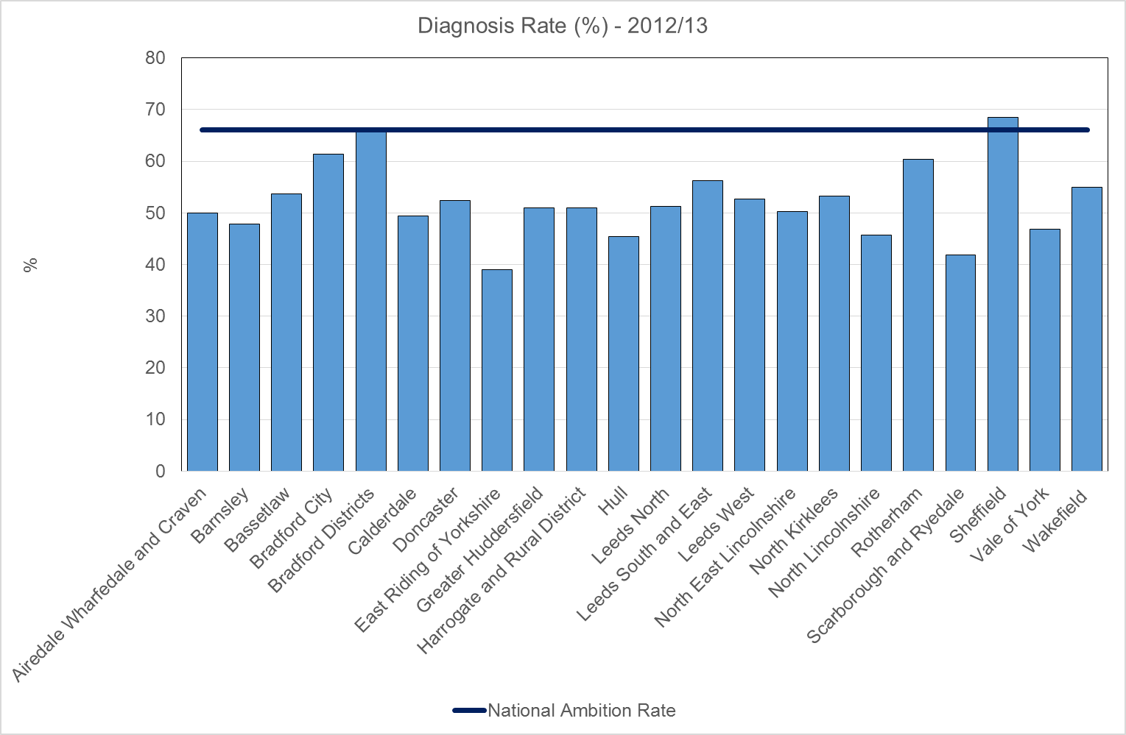

Source: National Dementia Prevalence Calculator (v3) - https://www.primarycare.nhs.uk/

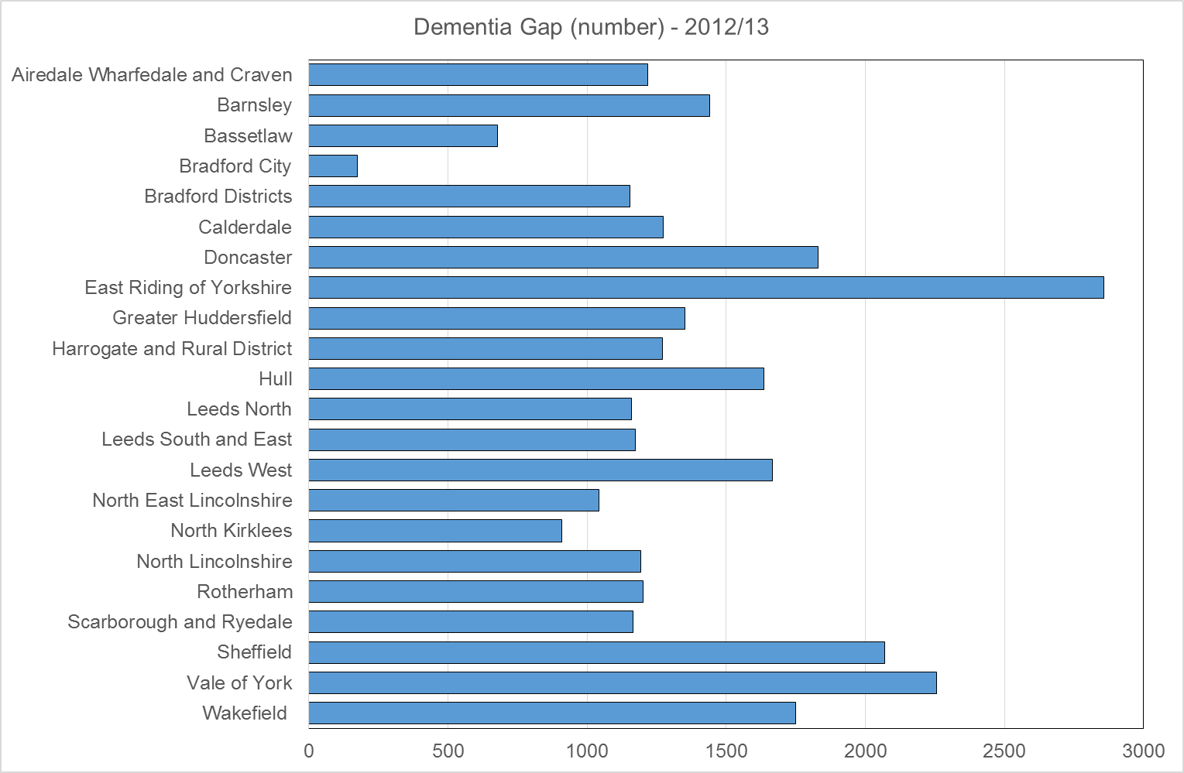

Source: National Dementia Prevalence Calculator (v3) - https://www.primarycare.nhs.uk/

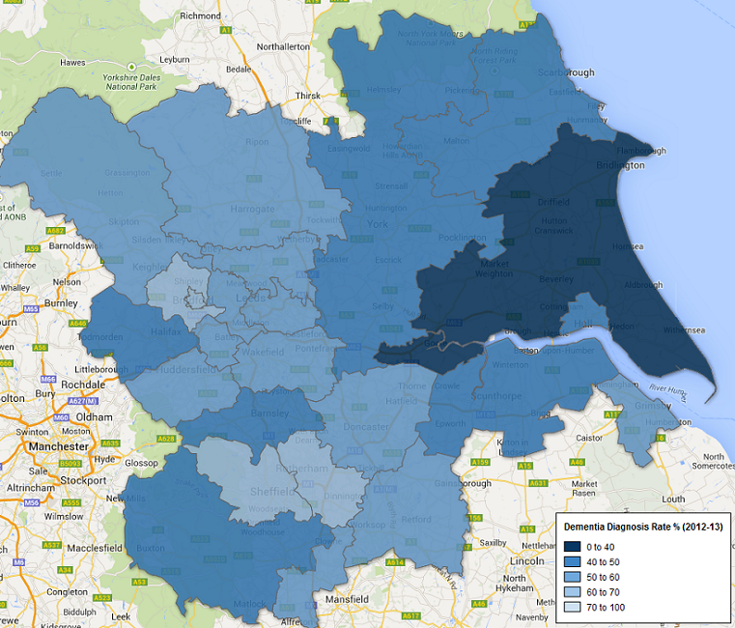

GP Practice Diagnosis Rates
The scatterplot below shows the current prevalence of dementia for each GP practice within Yorkshire & Humber, as a percentage of the expected prevalence for that practice, plotted against the expected number of patients with dementia. It clearly identifies current outlier practices. Plots for individual CCGs can be provided on request.

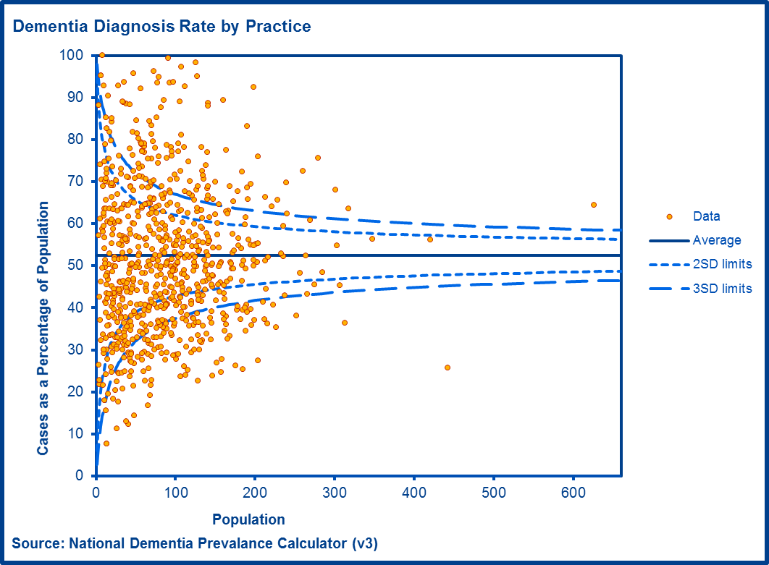

Dementia Enhanced Service (DES)
The enhanced service for dementia is designed to encourage GP practices to take a proactive approach to the timely assessment of patients who may be at risk of dementia. Participation in the DES is not mandatory, GP practices choose to participate and are remunerated for delivery against its various aspects.

The aims of the DES are to encourage GP practices to:

- identify patients at clinical risk of dementia
- offer an assessment to detect for possible signs of dementia in those at risk
- offer a referral for diagnosis where dementia is suspected
- in the case of a diagnosis, provide advanced care planning in line with the patient's wishes

The DES also aims to increase the health and wellbeing support offered to carers of patients diagnosed with dementia.
The DES states that practices should ‘make an opportunistic offer of assessment for dementia to “at-risk” patients on the practices registered list, where the attending practitioner considers it clinically appropriate to make such an offer’. At-risk groups include patients aged 60 and over with vascular disease or diabetes, those over 40 with Down’s syndrome, other patients over 50 with learning disabilities and patients with neurodegenerative disease.
The graph below shows percentage sign up to the DES for 2013/14. Practices are required to sign up for 2014/15 by end of April.

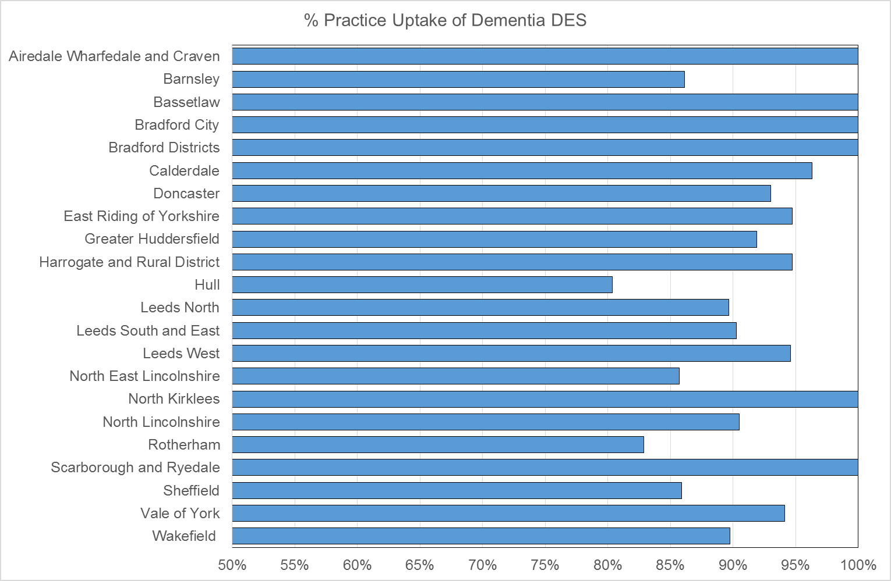

Estimates of Mild, Moderate or Severe Diagnoses
In the graph below, estimates of the percentage of patients with a dementia diagnosis who are in the mild, moderate or severe stage of the disease are applied to the expected number of people with dementia in each CCG. Although the needs of individuals will vary widely, these estimated figures are intended to support CCGs with service and resource planning.

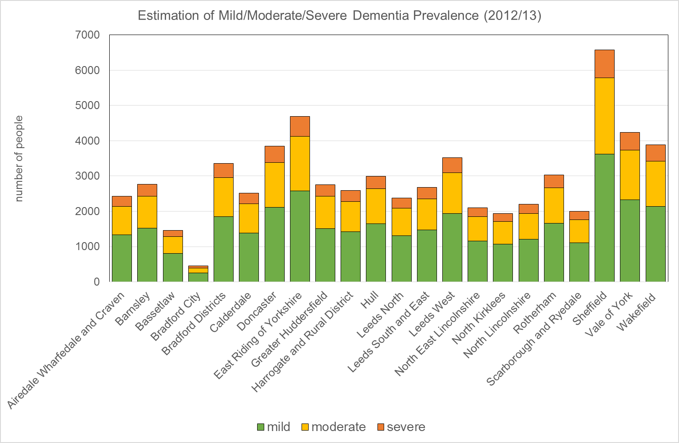

Source: National Dementia Prevalence Calculator (v3) - https://www.primarycare.nhs.uk/

Waiting Times

The information collected by the Diagnostic Imaging Dataset (DID) is sourced from the local Radiology Information System (RIS) of each provider.

The DID is a monthly collection of detailed information about diagnostic imaging tests carried out on NHS patients.

Based on all events where both a valid Date of Test Request and a valid Date of Test was present carried out in the financial year 2012-13.

For more information on the data collected, please see the documents on the HSCIC website http://www.hscic.gov.uk/did

Median Waits for Diagnostic Imaging by CCG

CCG | CT | MRI | PET | SPECT
Airedale, Wharfedale and Craven | 0 | 2 | 0 | 0
Barnsley | 0 | 4 | 6 | 25
Bassetlaw | 0 | 1 | 108 | 0
Bradford City | 1 | 4 | 0 | 0
Bradford Districts | 1 | 11 | 14 | 23
Calderdale | 0 | 3 | 4 | 0
Doncaster | 0 | 3 | 0 | 18
East Riding of Yorkshire | 0 | 3.5 | 14 | 0
Greater Huddersfield | 0 | 1 | 8.5 | 0
Harrogate and Rural District | 0 | 3 | 0 | 0
Hull | 0 | 2 | 0 | 0
Leeds North | 0 | 3 | 0 | 0
Leeds South and East | 0 | 4 | 6 | 0
Leeds West | 0 | 4 | 7.5 | 0
North East Lincolnshire | 1 | 0 | 0 | 35
North Kirklees | 0 | 7 | 0 | 0
North Lincolnshire | 0 | 4 | 0 | 6
Rotherham | 0 | 9.5 | 5 | 0
Scarborough and Ryedale | 0 | 10 | 0 | 0
Sheffield | 0 | 1 | 8 | 14
Vale of York | 1 | 7.5 | 0 | 0
Wakefield | 0 | 37 | 14 | 34

Median Waits for Diagnostic Imaging by Provider

 | CT | MRI | PET | SPECT
Airedale NHS Foundation Trust | 0 | 2 | 0 | 0
Barnsley Hospital NHS Foundation Trust | 0 | 4 | 0 | 0
Bradford Teaching Hospitals NHS Foundation Trust | 1 | 7 | 4 | 0
Calderdale and Huddersfield NHS Foundation Trust | 0 | 3 | 0 | 0
Chesterfield Royal Hospital NHS Foundation Trust | 0 | 3 | 0 | 0
Doncaster and Bassetlaw Hospitals NHS Foundation Trust | 0 | 2 | 0 | 0
Harrogate and District NHS Foundation Trust | 0 | 1 | 0 | 0
Hull and East Yorkshire Hospitals NHS Trust | 0 | 4 | 6.5 | 35
Leeds Teaching Hospitals NHS Trust | 0 | 4 | 7.5 | 31.5
Mid Yorkshire Hospitals NHS Trust | 0 | 0 | 0 | 0
Northern Lincolnshire and Goole Hospitals NHS Foundation Trust | 0 | 0 | 0 | 0
Rotherham NHS Foundation Trust | 0 | 0 | 0 | 0
Sheffield Children's NHS Foundation Trust | 0 | 0 | 0 | 0
Sheffield Teaching Hospitals NHS Foundation Trust | 0 | 1 | 7 | 17
York Teaching Hospital NHS Foundation Trust | 1 | 3 | 0 | 0

Memory Assessment Service

An audit was conducted of memory clinics in England between July and September 2013.
178 of 214 memory clinics in England responded, a response rate of 83%.

PCT | Provider | Waiting Time for Assessment | Waiting Time for Diagnosis
Barnsley PCT | South West Yorkshire Partnerships NHS Foundation Trust – Barnsley Memory Service | 5 weeks | 6 weeks
Bradford And Airedale Teaching PCT | Bradford District Care Trust – Bingley and North Bradford Memory Assessment and Treatment Service | 6 weeks | 10 weeks
Calderdale PCT | South West Yorkshire Partnerships NHS Foundation Trust – Calderdale Memory Service | 2 weeks | 7 weeks
Doncaster PCT | Rotherham, Doncaster and South Humber NHS Foundation Trust –Doncaster Memory Service | 2 weeks | 18 weeks
East Riding of Yorkshire PCT | No data
Hull Teaching PCT | Humber NHS Foundation Trust – Hull Memory Clinic | 6 weeks | 2 weeks
Kirklees PCT | No data
Leeds PCT | Leeds and York Partnerships NHS Foundation Trust – Leeds Memory Service | 13 weeks | 13 weeks
North East Lincolnshire Care Trust Plus | NAVIGO – Unity Mental Health and Memory Service | 2 weeks | 10 weeks
North Lincolnshire PCT | Rotherham, Doncaster and South Humber NHS Foundation Trust –MATS | 3 weeks | 18 weeks
North Yorkshire and York PCT | No data
Rotherham PCT | Rotherham, Doncaster and South Humber NHS Foundation Trust –Doncaster Memory Service | 2 weeks | 4 weeks
 | Rotherham, Doncaster and South Humber NHS Foundation Trust –Rotherham Memory Service | 7 weeks | 18 weeks
Sheffield PCT | Sheffield Health and Social Care NHS Trust – Sheffield Memory Service | 21 weeks | 9 weeks
Wakefield District PCT | South West Yorkshire Partnerships NHS Foundation Trust – Wakefield Memory Service | 3 weeks | 10 weeks

Local Survey (Jan 2014)

Locality | Time to assessment | Time to diagnosis
Airedale & Craven | 2-4 weeks for both – part of a single process
Bassetlaw | 4 to 6 weeks | Within 12 wks of GP referral (longer for complex patients)
Barnsley | No data
Bradford Locality | 2-3 months for both – part of a single process
Calderdale | ~ 5 weeks | ~ 12 weeks
Doncaster | 6 days | 4 weeks
Hull | 7.9 weeks | N/K
Leeds* | 25 days (Dec 2013) | 100 days (Dec 2013)
N Lincolnshire | No data
NE Lincolnshire | 5.9 days | 8 weeks
Rotherham | No data
Sheffield – SHSC | 16.5 weeks | 8.1 week
Wakefield | 5 weeks | 15 weeks (from assessment)

* Leeds introducing KPIs for both these measures as part of the LYPFT contract for Memory Services.

Dementia Commissioning for Quality and Innovation (CQUIN)

The Dementia CQUIN data collected by NHS England reports on the number and proportion of patients aged 75 and over, who were admitted to hospital as an emergency for more than 72 hours who have been identified as potentially having dementia, who are assessed and, where appropriate, referred to specialist services.

This report presents the year-to-date of data from the NHS England's data collection on the number and proportion of patients aged 75 and over admitted as an emergency for more than 72 hours who have been identified as potentially have dementia, who are appropriately assessed and, where appropriate, are referred on to a specialist services.

All providers of NHS-funded acute care are required to return data, and the collection has been mandatory since April 2013.

Cases Identified

Name | No. cases identified | No. of emergency admissions | % identified
Airedale | 1934 | 2333 | 82.9%
Barnsley | 2533 | 3339 | 75.9%
Bradford | 2878 | 2878 | 100%
Calderdale-Huddersfield | 3852 | 4016 | 95.9%
Chesterfield | 2814 | 3158 | 89.1%
Doncaster & Bassetlaw | 5783 | 6371 | 90.8%
Harrogate | 1349 | 1449 | 93.1%
Hull | 4255 | 4682 | 90.9%
Leeds | 7141 | 7608 | 93.9%
N Lincolnshire & Goole | 856 | 1704 | 50.2%
Mid Yorkshire | - | - | -
Rotherham | 1519 | 2139 | 71%
Sheffield | 6089 | 6164 | 98.8%
York | 6279 | 6806 | 92.3%

* Entries have been marked as ' - ' where the provider either did not submit a return for that specific month or was not recording the assessments carried out for the data collection

Source: http://www.england.nhs.uk/statistics/statistical-work-areas/dementia/

Diagnostic Assessment

Name | No. of cases with diagnostic assessment | No. of cases with positive case finding question | % diagnosed
Airedale | 367 | 503 | 73%
Barnsley | - | - | -
Bradford | 47 | 47 | 100%
Calderdale-Huddersfield | 582 | 584 | 99.7%
Chesterfield | 454 | 483 | 94%
Doncaster & Bassetlaw | - | - | -
Harrogate | 155 | 155 | 100%
Hull | 401 | 406 | 98.8%
Leeds | 758 | 801 | 94.6%
N Lincolnshire & Goole | 156 | 158 | 98.7%
Mid Yorkshire | - | - | -
Rotherham | 499 | 567 | 88%
Sheffield | 2075 | 2077 | 99.9%
York | 1606 | 1631 | 98.5%

Referred

Name | No. of cases referred | No. of cases with positive or inconclusive diagnostic assessment | % of cases referred
Airedale | 13 | 13 | 100%
Barnsley | 0 | 0 | -
Bradford | 47 | 47 | 100%
Calderdale-Huddersfield | 349 | 367 | 95.1%
Chesterfield | 300 | 312 | 96.2%
Doncaster & Bassetlaw | - | - | -
Harrogate | 112 | 112 | 100%
Hull | 326 | 336 | 97%
Leeds | 510 | 527 | 96.8%
N Lincolnshire & Goole | 5 | 156 | 3.2%
Mid Yorkshire | - | -
Rotherham | 1217 | 1217 | 100%
Sheffield | 30 | 44 | 68.2%
York | 1085 | 1094 | 99.2%

Post-Diagnosis

Prescribing Data

The data presented below is the latest available prescribing data for Q1 and Q2 2013/14 and provided by the HSCIC.

This information was obtained from the Prescribing Analysis and CosT tool (PACT) system, which covers prescriptions prescribed by GPs, nurses, pharmacists and others in England and dispensed in the community in the UK.

For data at CCG level, prescriptions written by a prescriber located in a particular CCG but dispensed outside that CCG will be included in the CCG in which the prescriber is based. The data available in PACT is a rolling 60 month dataset. Prescriptions written in England but dispensed outside England are included. Prescriptions written in hospitals /clinics that are dispensed in the community, prescriptions dispensed in hospitals, dental prescribing and private prescriptions are not included in PACT data. It is important to note this as some BNF sections have a high proportion of prescriptions written in hospitals that are dispensed in the community. For example, BNF chapter 4, ""Central Nervous System"" has a fair proportion of items written in mental health clinics that are dispensed in the community - these prescriptions are not included in PACT data."

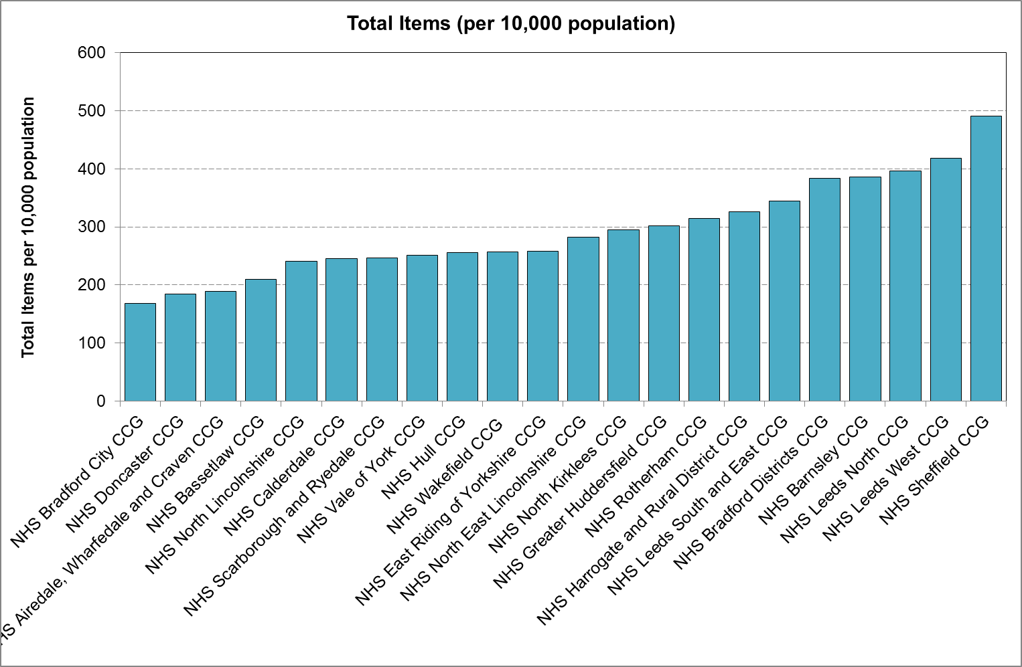

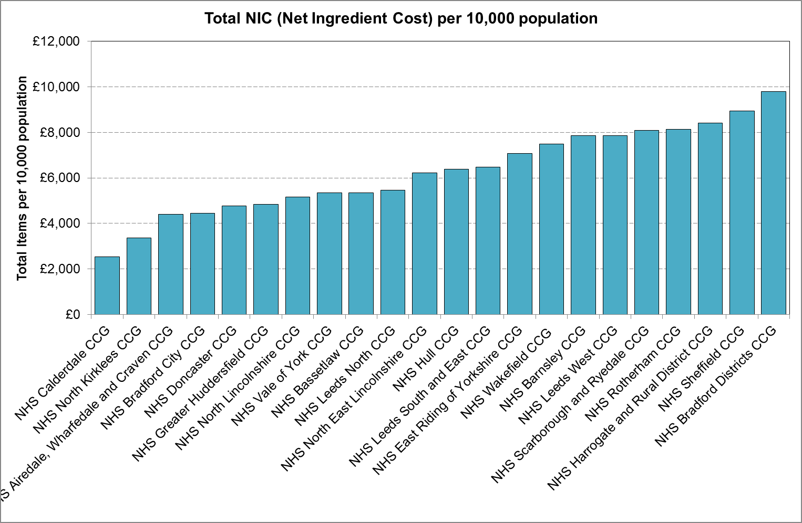

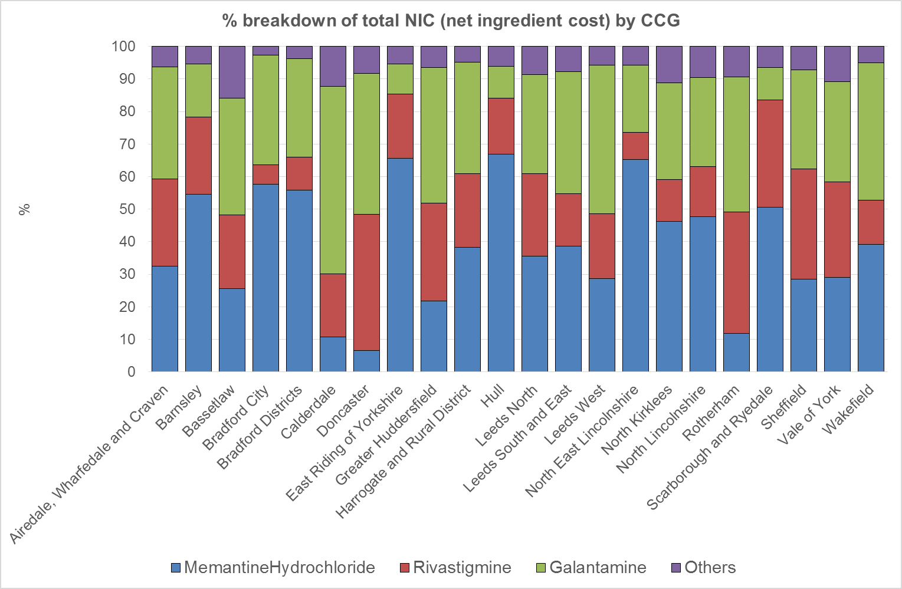

Acute Hospital Admissions

To be developed.

Anti-psychotic prescriptions

In July 2012, the National Dementia and Antipsychotic Prescribing Audit of 3,850 GP practices, covering 196,695 people with a diagnosis of dementia, reported a 52 per cent reduction in the prescribing of antipsychotic medication for people with dementia between 2006 and 2011.The Department of Health is rerunning the national audit to monitor the level of prescribing and regional variation. The audit results are expected to be available in spring 2014.

PCT | Number of participating practices | % of participating practices
Barnsley PCT | 29 | 63
Bradford And Airedale Teaching PCT | 2 | 2.4
Calderdale PCT | 3 | 10.3
Doncaster PCT | 6 | 13.3
East Riding of Yorkshire PCT | 16 | 41
Hull Teaching PCT | 14 | 23.3
Kirklees PCT | 11 | 15.1
Leeds PCT | 25 | 21.6
North East Lincolnshire Care Trust Plus | 20 | 58.8
North Lincolnshire PCT | 6 | 27.3
North Yorkshire and York PCT | 37 | 37
Rotherham PCT | 26 | 65
Sheffield PCT | 60 | 63.2
Wakefield District PCT | 2 | 4.8

End of Life
Median survival following diagnosis is 2 to 4 years, and the trajectory of decline is characterised by progressive functional and cognitive deterioration, with acute illnesses such as infection frequently precipitating death.

Given the expanding population with the disease, providing good quality end of life care in dementia is an enormous challenge.

There were 397,513 deaths with a mention of dementia recorded in England between 2001 and 2010. These comprised 6.6% (95% CI 6.5 to 6.7) of all deaths in 2001, almost doubling to 12.0% (95% CI 11.9 to 12.1) of all deaths in 2010.

Most patients died in care home (55.3%) or hospital (39.6%). Very few deaths occurred at home (4.8%) or inpatient hospices (0.3%). Just under half of all deaths were certified with dementia as underlying cause of death (46.5%). These patients were more likely to be women, older, and die in care homes.

Deaths amongst people with a death certificate mention of dementia in England have started to shift from hospitals to care homes.

Wolfson C, Wolfson DB, Asgharian M, M’Lan CE, Ostbye T, Rockwood K, Hogan DB, Clinical Progression of Dementia Study G: A re-evaluation of the duration of survival after the onset of dementia. N Engl J Med 2001, 344(15):1111–1116
Xie J, Brayne C, Matthews FE, Medical Research Council Cognitive Function and Ageing Study Collaborators: Survival times in people with dementia: analysis from population based cohort study with 14 year follow-up. BMJ 2008, 336(7638):258–262
Mitchell SL, Teno JM, Kiely DK, Shaffer ML, Jones RN, Prigerson HG, Volicer L, Givens JL, Hamel MB: The clinical course of advanced dementia. N Engl J Med 2009, 361(16):1529–1538
Sachs GA, Shega JW, Cox-Hayley D: Barriers to excellent end-of-life care for patients with dementia. J Gen Intern Med 2004, 19(10):1057–1063
Sleeman et al, BMC Neurology 2014, 14:59

